
Support Our GA State Youth All Stars!
1500 Thread Count Soft Luxury Sheet Sets
Sets include (1) Flat Sheet, 1 (18”) Deep Pocket Fitted Sheet and (2) Pillowcases
*$49.95 with Online Fundraiser Code GAAllstars before the Fundraiser ends*
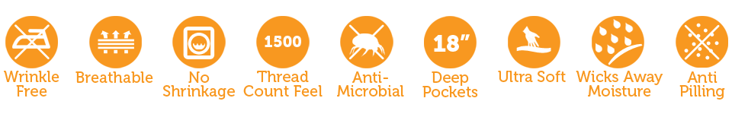
Visit www.peachskinsheets.com and select your sets at $79.95 each. When checking out,
type “GAAllstars” in the DISCOUNT CODE box for an automatic $30 off of your purchase!
Your order ships straight to you within two business days - no waiting for the fundraiser to close! Our team gets $20 for each Sheet Set sold! Please note that fundraiser pricing
cannot be combined with other promo codes, discounts, or specials
including Colors of the Month pricing.
Thank you for supporting us.


